1. **LAMPIRAN HASIL OUTPUT SPSS**

**Frequencies**

|  |  |  |  |
| --- | --- | --- | --- |
| **Statistics** | | | |
|  | | usia | pekerjaan |
| N | Valid | 400 | 400 |
| Missing | 0 | 0 |

|  |  |  |  |  |  |
| --- | --- | --- | --- | --- | --- |
| **pekerjaan** | | | | | |
|  | | Frequency | Percent | Valid Percent | Cumulative Percent |
| Valid | Aktor | 1 | .3 | .3 | .3 |
| Belum bekerja | 1 | .3 | .3 | .5 |
| Freelancer | 1 | .3 | .3 | .8 |
| Freshgraduate | 1 | .3 | .3 | 1.0 |
| Honor pegawai BUMD | 1 | .3 | .3 | 1.3 |
| Influencer | 1 | .3 | .3 | 1.5 |
| Karyawan kredivo | 1 | .3 | .3 | 1.8 |
| Karyawan PNM | 1 | .3 | .3 | 2.0 |
| Mahasiswa & Pegawai Swasta | 1 | .3 | .3 | 2.3 |
| Online shop | 1 | .3 | .3 | 2.5 |
| Owner online shop | 1 | .3 | .3 | 2.8 |
| Pegawai BUMN | 3 | .8 | .8 | 3.5 |
| Pegawai Negeri Sipil | 6 | 1.5 | 1.5 | 5.0 |
| Pegawai PT. Kereta Commuter Indonesia | 1 | .3 | .3 | 5.3 |
| Pegawai Swasta | 64 | 16.0 | 16.0 | 21.3 |
| Pelajar/Mahasiswa | 294 | 73.5 | 73.5 | 94.8 |
| Pencari kerja | 1 | .3 | .3 | 95.0 |
| PPNPN | 1 | .3 | .3 | 95.3 |
| Stay at home | 1 | .3 | .3 | 95.5 |
| Talent | 1 | .3 | .3 | 95.8 |
| usaha | 1 | .3 | .3 | 96.0 |
| Wiraswasta | 16 | 4.0 | 4.0 | 100.0 |
| Total | 400 | 100.0 | 100.0 |  |

**Regression**

|  |  |  |  |
| --- | --- | --- | --- |
| **Coefficientsa** | | | |
| Model | | Collinearity Statistics | |
| Tolerance | VIF |
| 1 | Kredibilitas | .651 | 1.535 |
| Daya Tarik Humor | .651 | 1.535 |
| a. Dependent Variable: Sikap Khalayak | | | |

|  |  |  |  |  |  |  |  |  |  |
| --- | --- | --- | --- | --- | --- | --- | --- | --- | --- |
| **Model Summary** | | | | | | | | | |
| Model | R | R Square | Adjusted R Square | Std. Error of the Estimate | Change Statistics | | | | |
| R Square Change | F Change | df1 | df2 | Sig. F Change |
| 1 | .879a | .773 | .772 | .38923 | .773 | 675.727 | 2 | 397 | .000 |
| a. Predictors: (Constant), Daya Tarik Humor, Kredibilitas | | | | | | | | | |

|  |  |  |  |  |  |  |
| --- | --- | --- | --- | --- | --- | --- |
| **ANOVAa** | | | | | | |
| Model | | Sum of Squares | df | Mean Square | F | Sig. |
| 1 | Regression | 204.745 | 2 | 102.372 | 675.727 | .000b |
| Residual | 60.145 | 397 | .151 |  |  |
| Total | 264.890 | 399 |  |  |  |
| a. Dependent Variable: Sikap Khalayak | | | | | | |
| b. Predictors: (Constant), Daya Tarik Humor, Kredibilitas | | | | | | |

|  |  |  |  |  |  |  |  |
| --- | --- | --- | --- | --- | --- | --- | --- |
| **Coefficientsa** | | | | | | | |
| Model | | Unstandardized Coefficients | | Standardized Coefficients | t | Sig. | Correlations |
| B | Std. Error | Beta | Zero-order |
| 1 | (Constant) | -.650 | .116 |  | -5.609 | .000 |  |
| Kredibilitas | .512 | .040 | .377 | 12.714 | .000 | .732 |
| Daya Tarik Humor | .675 | .033 | .602 | 20.332 | .000 | .825 |
| a. Dependent Variable: Sikap Khalayak | | | | | | | |

**Charts**

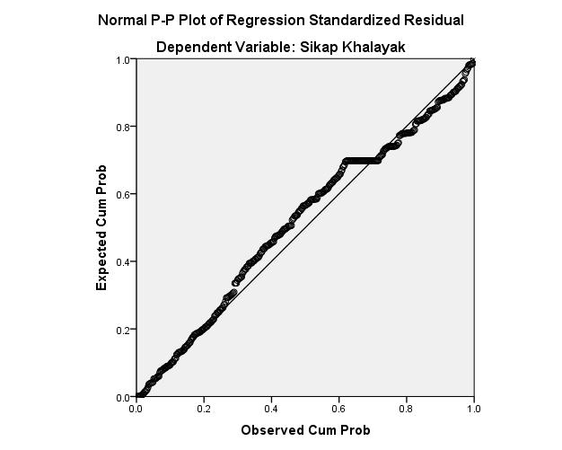

**Correlations**

|  |  |  |
| --- | --- | --- |
| **Correlations** | | |
|  | | Sikap Khalayak |
| Kredibilitas | Pearson Correlation | .732 |
| Sig. (2-tailed) | .000 |
| N | 400 |
| Daya Tarik Humor | Pearson Correlation | .825 |
| Sig. (2-tailed) | .000 |
| N | 400 |