COMPARISON OF ABTS (2,2-AZINOBIS(3-ETHYLBENZOTHIAZOLINE)-6-SULFONIC ACID) AND DPPH (1,1-DIPHENYL-2-PICRYLHYDRAZYL) ASSAYS TO MEASURE THE ANTIOXIDANT ACTIVITY OF ETANOL EXTRACT OF RED ALGA (Gelidium sp)

Ardi Rustamsyah^{1*}, Tien Ellita Endah Puspitasari¹, Isye Martiani¹, Dani Sujana²
¹Department of Pharmacy, Faculty of Mathematics and Natural Sciences, University of Garut, Jl. Jati No. 42B, Tarogong Kaler, West Java, 44151, Indonesia
²Diploma Program of Pharmacy, Karsa Husada Garut College of Health Sciences (STIKes Karsa Husada Garut), Jl. Nusa Indah No.24, Tarogong Kidul, 44151, West Java, Indonesia

Ardi Rustamsyah (ardi@uniga.ac.id)

ARTICLE HISTORY
| Received: | Revised: | Accepted:

Abstract
Seaweeds have ecological function as primary producers in marine waters. It also has an important economic value as producers of hydrocolloids (alginate, agar, and carragenan) that use in various industries of food and pharmaceuticals. This study aims to determine the antioxidants activity from red algae (Gelidium sp). Extraction was done by maceration method using ethanol 96% and concentrated by rotary evaporation. The antioxidant activity of extract was tested using ABTS and DPPH method. Antioxidant activity was seen from the IC₅₀. The results showed that IC₅₀ from ethanol extract of red algae (Gelidium sp) with DPPH method is 3,9154 ppm. Then using ABTS method, IC₅₀ from ethanol extract of red algae (Gelidium sp) is and 9,1178 ppm. This result shows that the ethanol extract from red algae (Gelidium sp) has very strong antioxidant activity (<50 ppm).
Keywords : Red Algae, Antioxidant, ABTS, DPPH

Introduction
Indonesia's coastline is approximately 99,093 kilometers long and its waters cover an area of approximately 3.2 million square kilometers. This area is rich in biological and non-biological natural resources, including the minerals contained therein.¹ One of the fishery commodities that can be used as one of the mainstays of the economy in Indonesia is seaweed. Indonesia's strategic location and abundant seaweed production make Indonesia the second largest seaweed producer after China.² According to its classification, seaweed can be grouped into three major groups, namely red algae (Rhodophyta), brown algae (Phaeophyta), and green algae (Chlorophyta).³ Various studies have shown that seaweed contains bioactive compounds such as carotenoids, phenol compounds and sulfate derivatives, polysaccharides and vitamins. These compounds have benefits, namely as antioxidants that can prevent free radicals.^{4,5}
Antioxidant activity methods can determine the characteristics of different antioxidants in a sample. There are various methods that can be used to measure the total characteristics of antioxidants,⁶ however, there is no single method that is considered to be the most ideal. Different activity methods may result in different antioxidant mechanisms of action.⁷ Some methods that can be used to analyze antioxidant activity include DPPH (1,1-Diphenyl-2-Picrylhydrazyl) and ABTS ((2,2-Azinobis(3-Ethylbenzothiazoline)-6-Sulfonic Acid)). Both methods use the same principle, which is the ability of antioxidant compounds to reduce free radicals or free radical radical oxidizers. The difference is in the free radical compounds used, namely ABTS and DPPH.⁸
In connection with the content of active ingredient compounds contained in seaweed that are beneficial for health and beauty, an observation or review of the antioxidant activity of ethanol extracts of red algae (Gelidium sp) using the ABTS and DPPH methods was conducted. Thus, the purpose of this study is to evaluate the comparability of antioxidant activity measurements obtained by ABTS and DPPH tests from ethanol extracts of Gelidium sp.
Instruments and Materials
UV-Vis spectrophotometer (Shimadzu®), analytical balance (Acis®), hot plate (IKA®), micropipette, pipette, filter paper, beaker glass (Pyrex®), measuring cup (Pyrex®), beaker (Pyrex®), rotary evaporator (Buchi®) and blender (Philips®).
The materials used in this study include Gelidium sp red algae samples from Pameungpeuk, West Java, Indonesia, ethanol 96% (Brataco®), methanol p.a (Brataco®), ethanol p.a (Brataco®), DPPH (Sigma Aldrich®), ABTS (Sigma Aldrich®), potassium persulfate (Emsure®), aquadest.
Experimental Procedure
Sample Preparation
Red algae (Gelidium sp ) samples were sorted then washed and dried. The dried samples were pulverized using a blender and then stored in a dry and tightly closed place.
Preparation of Ethanol Extract of Gelidium sp
480 g sample was macerated using 96% ethanol for 3x24 hours with occasional stirring, then filtered. The filtrate obtained was then concentrated using a rotary evaporator to obtain a thick extract. The extract obtained was calculated as a percentage rendement using the equation:
% Rendement = $\frac{weight extract}{Ssimplicia weight}$ x 100%

Antioxidant Activity Assay by ABTS Method

Preparation of ABTS 7 mM Stock Solution

20 mg of ABTS was dissolved with 5 mL of distilled water, then incubated at room temperature for 12-18 hours. Then weighed 3.5 mg of potassium persulfate dissolved with 5 mL of distilled water, then incubated at room temperature for 12-18 hours. Then the ABTS and potassium persulfate solutions were mixed and diluted with 25 mL of ethanol p.a in a glass volumetric flask.

Preparation of 1000 ppm Vitamin C Stock Solution

50 mg of vitamin C was weighed and then dissolved to 25 mL with ethanol p.a in a glass volumetric flask.

Preparation of 1000 ppm Gelidium sp Ethanol Extract Stock Solution

50 mg of Gelidium sp ethanol extract was weighed, then dissolved with 50 mL of ethanol p.a in a glass volumetric flask.

Blank Absorbance Measurement

3 mL of ABTS stock solution was taken and then read the wavelength with a UV-VIS spectrophotometer at a wavelength of 400-800 nm, then measured the absorbance with a UV-VIS spectrophotometer at the maximum wavelength obtained.

ABTS Binding Activity Assay with Vitamin C

This procedure was carried out by pipetting 20, 40, 60, 80, and 100 mL of vitamin C stock solution and then filling each of them up to the volume of a 10 mL volumetric flask with ethanol p.a so that a solution with a concentration of 2, 4, 6, 8, and 10 ppm was obtained. From the solution, 1 mL of solution was taken and 2 mL of ABTS stock solution was added. The solution was incubated for 15 minutes and measured the absorbance of the sample using a UV-VIS spectrophotometer at a maximum wavelength of 737 nm.

Analysis of ABTS Binding Activity with Gelidium sp Extracts
Sampling was done by pipetting 20, 40, 60, 80, and 100 mL of the Gelidium sp ethanol extract stock solution and then filling each to a volume of 10 mL in a volumetric flask with ethanol p.a so that a solution with a concentration of 2, 4, 6, 8, and 10 ppm was obtained. From the solution, 1 mL of solution was taken and 2 mL of ABTS stock solution was added. The solution was incubated for 15 minutes and measured the absorbance of the sample using a UV-VIS spectrophotometer at a maximum wavelength of 737 nm.
Antioxidant Activity Assay with DPPH Method

Preparation of 50 ppm DPPH Stock Solution

5 mg of DPPH was weighed and then dissolved with 100 mL of methanol p.a in a glass volumetric flask.

Preparation of 1000 ppm Vitamin C Stock Solution

Weighed 50 mg of vitamin C then dissolved with 50 mL of methanol p.a in a glass volumetric flask.

Preparation of 1000 ppm Gelidium sp Extract Stock Solution

50 mg of ethanol extract of Gelidium sp was weighed and then dissolved with 50 mL of methanol p.a in a glass volumetric flask.

Blank Absorbance Measurement

3 mL of DPPH stock solution was taken, then wavelength scanning was carried out with a UV-VIS spectrophotometer at a wavelength of 400-800 nm, then the absorbance was measured using a UV-VIS spectrophotometer at the maximum wavelength obtained.

DPPH Binding Activity Assay with Vitamin C

The measurements were carried out by pipetting 20, 30, 40, 50, and 60 µL respectively from the vitamin C stock solution and then filling each up to a volume of 10 mL volumetric flask with methanol p.a so that a solution with a concentration of 2, 3, 4, 5, and 6 ppm was obtained. From the solution then taken 1 mL of solution and added 2 mL of DPPH stock solution. The solution was incubated for 30 minutes and then measured the absorbance of the sample using a UV-VIS spectrophotometer at a maximum wavelength of 516 nm.

Analysis of DPPH Binding Activity with Gelidium sp Extracts

The evaluation was carried out by pipetting 20, 40, 60, 80, 100, and 120 mL respectively from the extract stock solution and sufficed each up to a volume of 10 mL volumetric flask using methanol p.a so as to obtain a solution with a concentration of 2, 4, 6, 8, 10, and 12 ppm. From the solution then taken 1 mL of solution and added 2 mL of DPPH stock solution. The solution was incubated for 30 minutes and measured the absorbance of the sample using a UV-VIS spectrophotometer at a maximum wavelength of 516 nm.
Data Analysis
Antioxidant activity can be known by obtaining % inhibition data and IC₅₀ which states the concentration that can reduce free radicals by 50%. The percent inhibition value can be determined by the use of the calculation below:
% inhibition = $\frac{Blanko Absorbance-Sample Absorbance}{Blanko Absorbance}$ x 100%
Result and Discussion
Table 1. Rendement
Simplicia Weight (g) | Extract Weight (g) | Rendement (%)
3.1535 | 3.1531 | 0.8298
The result of the extraction obtained the yield of ethanol extract of Gelidium sp amounted to 0.8298%. This result is smaller than the previous report which amounted to 0.9%. The extraction yield depends on the solubility of the bioactive components.⁹
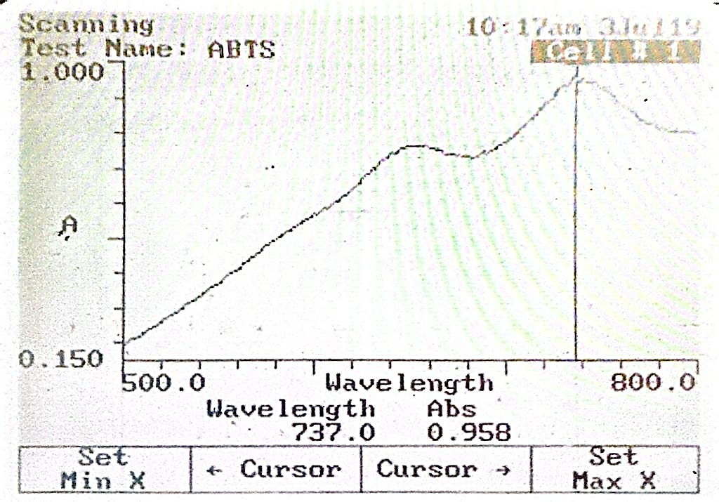  (A) | 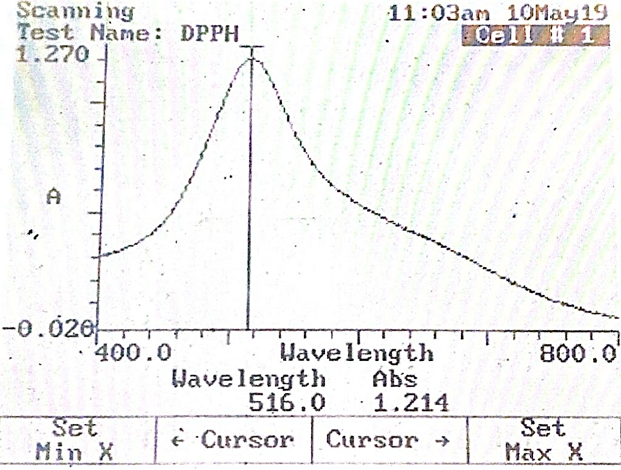 (B)

Figure 1. Scanning results of ABTS (A) and DPPH (B) wavelengths

The antioxidant activity of Gelidium sp ethanol extract by ABTS and DPPH methods using vitamin C as a positive control, obtained wavelengths of 737 and 516 nm, respectively.

Table 2. Antioxidant Assay Results Using the ABTS Method
Sample Solution | C (ppm) | Absorbance (nm) |  | % Inhibition | IC₅₀ (ppm)
 |  | x̅ | x̅ ± SD
Vitamin C | 2 | 0.7230 | 0.7230±0.0008 | 28.8386 | 5.6396
 | 4 | 0.6120 | 0.6120±0.0008 | 39.7638
 | 6 | 0.4870 | 0.4870±0.0008 | 52.0669
 | 8 | 0.3607 | 0.3607±0.0005 | 64.5013
 | 10 | 0.2493 | 0.2493±0.0005 | 75.4593
Gelidium sp ethanol extract | 2 | 0.5853 | 0.5853±0.0009 | 38.9005 | 9.1178
 | 4 | 0.5510 | 0.5510±0.0008 | 42.4843
 | 6 | 0.5237 | 0.5237±0.0005 | 45.3375
 | 8 | 0.4947 | 0.4947±0.0017 | 48.3646
 | 10 | 0.4677 | 0.4677±0.0005 | 51.1830
Tabel 3. Antioxidant Assay Results Using the DPPH Method
Sample Solution | C (ppm) | Absorbance (nm) |  | % Inhibition | IC₅₀ (ppm)
 |  | x̅ | x̅ ± SD
Vitamin C | 2 | 0.6557 | 0.6557±0.0012 | 45.9912 | 2.4451
 | 3 | 0.5557 | 0.5557±0.0005 | 54.3932
 | 4 | 0.4257 | 0.4257±0.0012 | 64.6897
 | 5 | 0.3257 | 0.3257±0.0005 | 73.2565
 | 6 | 0.2257 | 0.2257±0.0005 | 81.4113
Gelidium sp ethanol extract | 2 | 0.6977 | 0.6977±0.0012 | 42.5316 | 3.9154
 | 4 | 0.6020 | 0.6020±0.0024 | 50.4119
 | 6 | 0.5130 | 0.5130±0.0008 | 57.743
 | 8 | 0.4080 | 0.4080±0.0008 | 66.3921
 | 10 | 0.3020 | 0.3020±0.0008 | 75.1236
 | 12 | 0.2133 | 0.2133±0.0005 | 82.4272

Many of the tests use the same principle, assessing the ability of the sample to capture radicals or reduce redox active compounds monitored by a spectrophotometer. In addition, there are two types of assays. One approach is based on electron transfer and involves the reduction of colored oxidants, for example in ABTS and DPPH assays. This study reports that the ethanol extract of Gelidium sp has an IC₅₀ value of 9.1178 ppm from the results with the ABTS method, while the results with the DPPH method are 3.9154 ppm. From both results when compared with vitamin C (IC₅₀ of 5.6396 ppm by ABTS method and IC₅₀ of 2.4451 ppm by DPPH method). Although the antioxidant activity of both methods is still low compared to vitamin C, it is still included in the category of very strong antioxidants (IC₅₀<50 ppm). This finding is in line with the previous report, where the ethanol extract of Gelidium sp has very strong antioxidant activity with IC₅₀ value of 22.15±1.63.¹⁰ This represents the antiradical activity that can reduce 50% of free radical activity by an antioxidant agent.¹¹ In specifications, the ABTS assay is based on the formation of blue or green ABTS⁻⁺ that can be reduced by antioxidants, while the DPPH assay is based on the reduction of purple DPPH to 1,1-diphenyl-2-picryl hydrazine. Both assay methods are generally widely used, but limitations lie in their use of non-physiological radicals.¹²

Conclusion

Taken together, the findings of this study indicate that the antioxidant activity test using the DPPH method is superior to the ABTS method on the ethanol extract of Gelidium sp, where the IC₅₀ value of the DPPH method test results is lower than the ABTS method.
Reference
1. Rustamsyah A, Sujana D, Kusmiyati M. Review : Aktivitas Farmakologi Rumput Laut Genus Gracilaria (Rhodopyceae). Jurnal Farmasi Sains dan Terapan. 2023;10(1):38-43. doi:10.33508/jfst.v10i1.4318
2. Husna S, Nurlaida, Yusriadi, Utami HH, Najmah. Komponen Fitokimia dan Aktivitas Antioksidan Rumput Laut Eucheuma Cottonii di Perairan Desa Pajukukang Bantaeng. Jurnal Crystal: Publikasi Penelitian Kimia dan Terapannya. 2023;5(2):9-15. https://doi.org/10.36526/jc.v5i2.2769
3. Kumar Y, Tarafdar A, Badgujar PC. Seaweed as a Source of Natural Antioxidants: Therapeutic Activity and Food Applications. J Food Qual. 2021;2021. https://doi.org/10.1155/2021/5753391
4. Nawaly H, Susanto AB, Uktolseja JLA. Senyawa Bioaktif Dari Rumput Laut Sebagai Antioksidan. In: Proceeding Biology Education Conference. ; 2013:1-8.
5. Sujana D, Saptarini NM, Sumiwi A, Levita J. Kadar Fenolik Total Ekstrak Temukunci (Boesenbergia rotunda L) Asal Lembang Jawa Barat Dengan Metode Folin-Ciocalteu. Medical Sains: Jurnal Ilmiah Kefarmasian. 2022;7(3). https://doi.org/10.37874/ms.v7i3.436
6. Maryam S, Baits M, Nadia A. Pengukuran Aktivitas Antioksidan Ekstrak Etanol Daun Kelor (Moringa oleifera Lam.) Menggunakan Metode Frap (Ferric Reducing Antioxidant Power). Jurnal Fitofarmaka Indonesia. 2015;2(2):115-118. https://doi.org/10.33096/jffi.v2i2.181
7. Siddeeg A, AlKehayez NM, Abu-Hiamed HA, Al-Sanea EA, AL-Farga AM. Mode of action and determination of antioxidant activity in the dietary sources: An overview. Saudi J Biol Sci. 2021;28(3):1633-1644. https://doi.org/10.1016/j.sjbs.2020.11.064
8. Theafelicia Z, Wulan SN. Perbandingan Berbagai Metode Pengujian Aktivitas Antioksidan (DPPH, ABTS dan FRAP) pada Teh Hitam (Camellia sinensis). Jurnal Teknologi Pertanian. 2023;24(1):35-44. https://doi.org/10.21776/ub.jtp.2023.024.01.4
9. Kurniawati I, Maftuch dan Hariati M.A. Penentuan Pelarut dan Lama Ekstraksi Terbaik pada Teknik Maserasi Gracilaria sp. Serta Pengaruhnya Terhadap Kadar Air dan Rendemen. Samakia: Jurnal Ilmu Perikanan. 2016;7(2):72-77.
10. Purwaningsih S, Deskawati E. Karakteristik dan Aktivitas Antioksidan Rumput Laut Gracilaria sp. Asal Banten. JPHPI. 2020;23(3):503-512. https://doi.org/10.17844/jphpi.v23i3.32808
11. Agustini NWS. Aktivitas Antioksidan dan Uji Toksisitas Hayati Pigmen Fikobiliprotein dari Ekstrak Spirulina platensis. In: Seminar Nasional IX Pendidikan Biologi FKIP UNS 535.; 2012:535-243.
12. Floegel A, Kim DO, Chung SJ, Koo SI, Chun OK. Comparison of ABTS/DPPH assays to measure antioxidant capacity in popular antioxidant-rich US foods. Journal of Food Composition and Analysis. 2011;24(7):1043-1048. https://doi.org/10.1016/j.jfca.2011.01.008

