**Fucoidan Nanoencapsulation From Brown Algae (S*argassum polycystum*) As A Potential Marine Immunomodulatory Agent**

**Ungsari Rizki Eka Purwanto1, Endang Diyah Ikasari2*, I Kadek Bagiana3,**

**Lia Kusmita4, Ni Nyoman Ayu Indah Trisnayanthi5, I Wayan Mudianta6, Rahmadi Prasetijo 7**

1,2,3,4 Sekolah Tinggi Ilmu Farmasi Yayasan Pharmasi, Semarang, Indonesia

*Jl. Letnan Jendral Sarwo Edie Wibowo Km. 1, Plamongan Sari, Kec. Pedurungan, Kota Semarang, Jawa Tengah 50192*

5,6,7 Indonesian Marine Education and Research Organization (MERO Foundation), Bali, Indonesia

*Jl. Muntig, Tulamben, Kec. Kubu, Kabupaten Karangasem, Bali 80853*

6 Department of Chemistry, Universitas Pendidikan Ganesha Singaraja, Bali, Indonesia

*Jalan Udayana No.11 Singaraja - Bali 81116*

7 Dhyana Pura University, Bali, Indonesia

*Jl. Raya Padang Luwih, Dalung, Kuta Utara, Kabupaten Badung, Bali 80351*

*Corresponding author: Endang Diyah Ikasari (endangdiyahikasari@gmail.com)

**ARTICLE HISTORY**

Received: Revised: Accepted:

**Abstract**

The quest for better and more effective treatments has encouraged the search for therapies derived from natural sources to obtain effective immune therapy considering that several pandemics have arisen caused by viruses. The development of fucoidan from brown algae in drug encapsulation as an immunomodulator could be more promising. This study aimed to produce nanoencapsulation loaded with fucoidan purified extract from brown algae and to evaluate the influence of nanoencapsulation formulation on the immunomodulatory activity of fucoidan. Fucoidan was obtained from brown algae and extracted by hot aqueous, followed by purification using ethanol. Nanoencapsulation of fucoidan purified extract was prepared by ionic gelation method. The carbon clearance method was carried out for the immunomodulatory activity test of the nanoencapsulation of fucoidan purified extract. Nanoencapsulation of fucoidan purified extract with the optimum composition of maltodextrin 9.9% and S-TPP 0.1% (1:5) resulted in particle size of 715.4 nm, zeta potential -0.1 mV, pH 7.54, transmittance 97.54%, and entrapment efficiency 89.94%. The carbon clearance test showed that the nanoencapsulation of fucoidan was a strong immunostimulant with a phagocytosis index of 1.65. The development of nanoencapsulation could increase the phagocytosis index of fucoidan purified extracts from brown algae. Further molecular studies are needed to demonstrate the molecular activity of this preparation as an immunomodulator.

**Keywords:** fucoidan, brown_algae, nanoencapsulation, immunomodulator

**Nanoenkapsulasi Fucoidan dari Alga Coklat (*Sargassum polycystum*) Sebagai Agen Imunomodulator dari**

**Bahan Alam Laut yang Potensial**

**Abstrak**

Pencarian pengobatan yang lebih baik dan efektif mendorong pencarian terapi yang berasal dari sumber alami untuk mendapatkan terapi imun yang efektif mengingat telah muncul beberapa pandemi yang disebabkan oleh virus. Pengembangan fukoidan dari alga coklat dalam enkapsulasi obat sebagai imunomodulator bisa lebih menjanjikan. Penelitian ini bertujuan untuk menghasilkan nanoenkapsulasi yang mengandung ekstrak fukoidan murni dari alga coklat dan mengevaluasi pengaruh formulasi nanoenkapsulasi terhadap aktivitas imunomodulator fukoidan. Fukoidan terpurifikasi diperoleh dari alga coklat dan diekstraksi dengan air panas, dilanjutkan dengan pemurnian menggunakan etanol. Nanoenkapsulasi ekstrak fukoidan terpurifikasi dibuat dengan metode gelasi ionik. Metode pembersihan karbon dilakukan untuk uji aktivitas imunomodulator nanoenkapsulasi ekstrak fukoidan terpurifikasi. Nanoenkapsulasi ekstrak fukoidan terpurifikasi dengan komposisi optimum maltodekstrin 9,9% dan S-TPP 0,1% (1:5) menghasilkan ukuran partikel 715,4 nm; potensial zeta -0,1 mV;, pH 7,54; transmitansi 97,54%; dan efisiensi penjerapan 89,94%. Uji pembersihan karbon menunjukkan bahwa nanoenkapsulasi fukoidan merupakan imunostimulan yang kuat dengan indeks fagositosis 1,65. Pengembangan nanoenkapsulasi dapat meningkatkan indeks fagositosis ekstrak fukoidan murni dari alga coklat. Studi molekuler lebih lanjut diperlukan untuk menunjukkan aktivitas molekuler dari sediaan ini sebagai imunomodulator.

**Kata kunci:** fukoidan, alga_cokelat, nanoenkapsulasi, imunomodulator

**Introduction**

The occurrence of a global pandemic due to SARS-CoV-2 and other viral diseases, as well as the search for better and more effective treatments, has encouraged research regarding the search for therapies derived from natural sources that are based on the regulation of the immune response. The immune system is an organism's defense mechanism that prevents and eliminates potentially dangerous pathogens(1). In addition, the immune response is enhanced by certain compounds called immunomodulators that influence the cellular and humoral immune systems, either by increasing or inhibiting function. Immune stimulants have been widely used to fight cancer, bacterial and viral infections, as well as immunodeficiency diseases. At the same time, immunosuppressants are used to treat autoimmune diseases and organ transplantation(2).

The potential of marine sulfated polysaccharides such as brown algae-derived fucoidan as immunomodulators in the prevention and treatment of virus, such as Covid-19 has received considerable interest(3–5). The main problem which limits its application in therapy is high molecular weight and the absorption rate of fucoidan in the intestine was only 0.6%(6). A study is needed to formulate fucoidan in a delivery system such as a nanoparticle, therefore fucoidan is not damaged by stomach acid and can be absorbed in the intestine with a higher absorption capacity.

Drug formulation development is increasingly focused on drug delivery systems. The nanoparticle matrix in the form of the encapsulated drug consisting of polymers can be derived from either natural polymers or synthetic polymers(7). Multiple drug analogs or target drugs encapsulated for a particular tissue may theoretically be more promising. It can reduce the dose of the drug, minimizes side effects, and improves patient compliance and therapeutic effect(8). Various biocompatible and degradable natural polymers can be used in the formation of nanoparticles through self-assembly methods. Several studies have succeeded in forming nanoparticles in the form of encapsulated drugs by the ionic gelation method, including combining chitosan with maltodextrin, chitosan with sodium tripolyphosphate (S-TPP)(9,10). Therefore, the research about encapsulating an marine drug such as fucoidan from brown algae (*Sargassum polycystum*) with a cross-linking agent such as chitosan, maltodextrin and or S-TPP need to be carried out. The objective of this study was to produce nanoencapsulation loaded with fucoidan purified extract from brown algae in optimum combination of crosslinkers and to evaluate the inﬂuence of nanoencapsulation formulation in immunomodulator activity of fucoidan.

**Materials**

The materials used for the manufacture of nanoencapsulations and determination of fucoidan were brown algae (*Sargassum polycystum*) from Pailus Beach, Jepara-Indonesia, fucoidan standard (Sigma aldirch, catalog no F1890), aquadest (MKR Chemicals Ltd, Indonesia), ethanol (Mallinckrodt Chemicals), chitosan (CV. Biochitosan Indonesia), maltodextrin (Qinhuangdao Strach, co.ltd, China), sodium tripolyphosphate (Arrow Fine Chemical, India). The materials used for the immunomodulator test were Swiss albino male mice, heparin (Inviclot®, Indonesia), gelatin (MKR Chemicals Ltd, Indonesia), sodium carboxy methyl cellulose (MKR Chemicals Ltd, Indonesia), carbon ink (Yamura®, Indonesia), formalin (MKR Chemicals Ltd, Indonesia), Sancoidan® (Sanbe Farma, Indonesia).

**Tools**

The tools used in this research were digital scales (O'Hauss), analytical scales, measuring cups, filter paper, magnetic stirrer, stopwatch, centrifuge (PLC series), sonicator (Branson 1800), UV-Vis 1280 spectrophotometer (Shimadzu), pH meter, FTIR spectrophotometer, and Particle Size Analyzer (Malvern).

**Methods**

**Preparation of Fucoidan Extraction and Purification from Brown Algae**

The fucoidan extraction procedure performed as described by Junaidi(11) with slight modification. 500 grams dried brown algae extracted with hot distilled water (1:10) in four hours of extraction. It would be air-dried and milled into powder prior to extraction by water solution to produce fucoidan crude extract. The fucoidan crude extract were then centrifuged at a speed of 3000 rpm for 10 minutes. Sediment was separated, and the liquid part (filtrate) was added with ethanol 70% for purification as with the same amount of the liquid part until a precipitate was formed. Centrifugation then be performed once again to separate sediment from the liquid. The final precipitate was separated, dried and these were the final stage of fucoidan purification. Fucoidan purification extract was analyzed for fucoidan content with FT-IR.

**Preparation of Nanoencapsulation Containing Fucoidan Purification Extract**

The fucoidan purification extract solution was made by the concentration 1 mg/mL. Preliminary tests were carried out to select the right combination of crosslinkers. In the preliminary test, several crosslinkers were tried to be combined. FP I: combination of chitosan and S-TPP, FP II: combination of chitosan and maltodextrin, FP III: combination of maltodextrin and S-TPP.

Fucoidan was weighed as much as 100 mg, then dissolved with distilled water at 100oC in a beaker glass and stirred until homogeneous. The solution was put into a measuring flask and stirred 100 mL with distilled water, so that a fucoidan solution with a concentration of 1 mg/mL was obtained. The chitosan solution was made by dissolving powdered chitosan within acetate buffer solution pH 4 and stirring with a magnetic stirrer until the chitosan was dissolved. Solution of maltodextrin and S-TPP as a crosslink were made in an aqueous solvent.

The crosslinker combination that produced the highest transmittance in the preliminary test would be optimized to obtain nanoencapsulation preparations that have the highest fucoidan adsorption efficiency. The optimization of the crosslinker combination was carried out with the help of software Design Expert 10. Crosslinkers were dissolved with distilled water and stirred with a magnetic stirrer until completely dissolved. The first crosslinker solution was put into a vial, then it was added with fucoidan solution in a concentration of 1 mg/mL and stirred with a magnetic stirrer at 1500 rpm for 30 minutes. The second crosslinker solution was taken using a volume pipette and then added to the vial. Stir again using a magnetic stirrer for 60 minutes. The mix solution formed was sonicated for 60 minutes. The manufacturing of nanoencapsulation was carried out for 3 cycles with a stirrer for 60 minutes and sonication for 60 minutes. Evaluation of nanoencapsulation solution test as an optimization response were :

**pH test**

The pH test was carried out using a pH meter (Trans Instruments Walklab Series®). Before being used to measure the pH of the preparation, the pH meter was calibrated with standard buffer solutions of pH 4 and pH 7.

**Transmittance Test**

An amount of approximately 5 mL of a nanoencapsulation solution was put into a cuvette, then the transmittance was measured at a wavelength of 650 nm. The blank used when measuring transmittance was aquadest(12).

**Entrapment Efficiency**

A good nanoparticle system should have a high drug loading capacity so as to reduce the use of the material as a matrix. Drug loading can be done by two methods, namely the combining method and the absorption method. Drug loading and adsorption efficiency are highly dependent on the solubility of the drug in the matrix or polymer, the molecular weight of the drug and the interaction of the polymer in the presence of ester or carboxyl functional groups(13). Fucoidan which was not absorbed in the encapsulation (free fucoidan in solution) was quantitatively determined by FT-IR. Entrapment efficiency(14) were calculated by using the following equations :

***% Entrapment Efficiency =***

$\frac{(total amount of fucoidan in solution-free fucoidan in solution)}{total amount of fucoidan in solution}$***x 100%*...............................(1)**

**Evaluation Characteristics of Nanoencapsulation Containing Fucoidan**

After obtaining the optimum formula from the nanoencapsulation solution, the particle size and potential zeta was analyzed with Particle Size Analyzer (PSA-Horiba®). Thereafter, the solution was dried using a freeze dryer and then its characteristics were evaluated. The morphological structure of nanoencapsulation was evaluated using Scanning Electron Microscopy (SEM-Horiba®). The samples was prepared by dropping solutions into copper grids coated with carbon using the auto carbon coated for 5 minutes prior to the samples drying. The samples was stayed in the copper network for 2–3 min. The samples were then immersed in 2% phosphotungstic acid stain and stain for 2–3 min. After natural drying, the samples were placed under SEM for observation(14).

**Immunomodulatory Effect**

**Carbon Ink Suspension**

1.6 ml of carbon ink (Yamura®) was taken and put into a mortar, added 0.5% sodium carboxy methyl cellulose (S-CMC) suspension dissolved in a 10 ml volumetric flask.

**Macrophage Phagocytosis by Carbon Clearance Method**

Tests for non-specific immune responses were based on phagocytic activity(15). Swiss albino male mice (25-30 g) were used. The animals were fed with standard pellet diet and water *ad libitum* and maintained under standard environmental conditions (22 ± 5°C with 12 h of light/dark cycle). All experimental protocols were approved by Health Research Ethics Commission (305/AHW-SW/KEPK/STIFAR /EC/XII/2021), Sekolah Tinggi Ilmu Farmasi Yayasan Farmasi Semarang, Indonesia.

Mice were divided into five groups of five mice each. Drugs were administered in various groups, i.e. Group I served as normal control (NC) and received distilled water, Group II served as negative control and received S-CMC 0.5% suspension, Group III received standard drug fucoidan as an aqueous suspension at a dose of 580 mg/kg, Group IV received nanoencapsulation containg fucoidan purification extract at a dose 580 mg/kg and Group V received Sancoidan® at a dose of 580 mg/kg. Every group was gave each drug orally at once a day for seven days. On eighth day, all the groups were given carbon ink suspension at a dose 10 ml/kg through the tail vein. Blood was collected from the retro-orbital plexuses of individual animals at 0, 5, 10, 15 and 20 min immediately after the injection of carbon suspension. Blood (25 *µ*l) was lysed with heparin 0.25 ml of heparin solution and 4 ml of 1% acetid acid and the absorbance was measured spectrophotometrically at 640,5 nm for determination of optical densities. Phagocytosis activity was determined based on the comparison between the slope of the linear regression line between transmittance with respect to time in the test and normal groups.

**Lymphoid Organ Index Testing**

The mice were euthanized using ether for several minutes until the mice lost consciousness. The mice were dissected and their lymphoid organs (liver, spleen, and lymph nodes) were removed. imus). The lymphoid organs were weighed and compared with the control group and the organ index (%).

**Data Analysis**

Test data for fucoidan purified extract nanoparticles from brown seaweed (*Sargassum polycystum*) includes tests pH, transmittance, and entraptment efficiency. Optimal formula parameters include pH test, transmittance, and adsorption efficiency. Determination of the optimal formula is calculated using Design Expert software using the Simplex Lattice Design method. The selected formula was then created again with the same test and then tested for validity using the T-test. Meanwhile, the phagocytosis index data in the immunomodulatory activity test will be analyzed statistically using one-way ANOVA using SPSS software.

**Result**

Brown algae (Picture 1) was taken from the shores of Pailus Beach, Jepara, Central Java. The sample was washed with sea water and dried in a drying cabinet for approximately 24 hours. Before drying, the sample was first cut into pieces to speed up the drying process. The brown algae used in the study was determined in the laboratory of the Department of Biology, Faculty of Math and Science, State University of Semarang, Indonesia. The purpose of determination was to get a clear identity of the raw materials under study and to avoid errors in the collection of the main research materials.

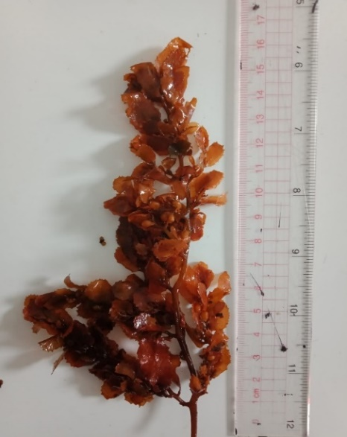

**Figure 1.** Brown Algae (*Sargassum polycystum*) from Pailus Beach, Jepara, Indonesia

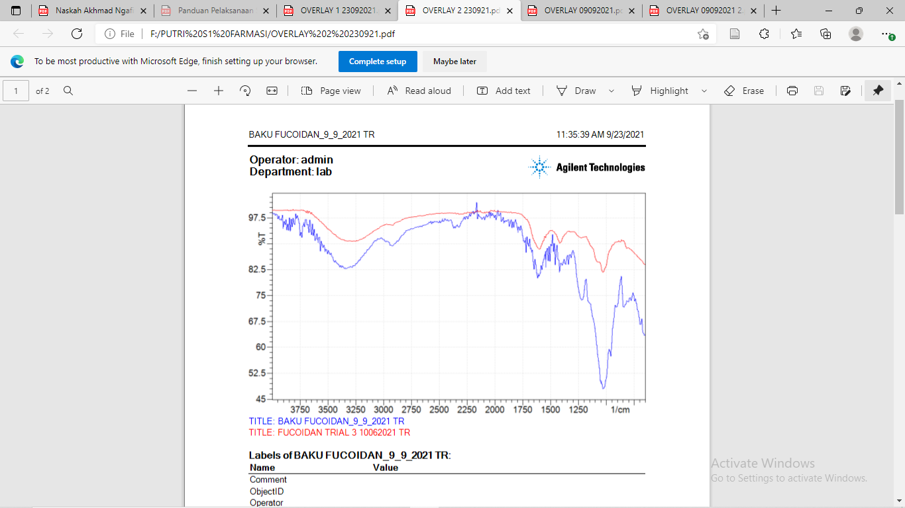

**B**

**A**

*A : Fucoidan purified extract*

*B : Fucoidan standard (Sigma Aldrich, catalog no: F1890)*

**Figure 2.** FT-IR Profile of Fucoidan Purified Extract of Brown Algae

**Table 2.** Pysichal Characteristic of Optimization Formulas of Fucoidan Purified Extract Nano-encapsulation

|  |  |  |  |  |  |
| --- | --- | --- | --- | --- | --- |
| **Formula** | **Proportion** | | **Response** | | |
| **Maltodextrin 9,9%** | **S-TPP 0,1%** | **Transmittance** | **pH** | **%EE** |
| 1 | 1 | 5 | 96.4 | 7.59 | 90.5 |
| 2 | 4 | 2 | 93.9 | 5.74 | 77.28 |
| 3 | 5 | 1 | 91.7 | 5.05 | 74.35 |
| 4 | 3 | 3 | 95.5 | 6.94 | 83.9 |
| 5 | 5 | 1 | 91.3 | 4.95 | 74.28 |
| 6 | 1 | 5 | 98.7 | 7.61 | 89.27 |
| 7 | 2 | 4 | 96.2 | 7.03 | 84.75 |
| 8 | 3 | 3 | 95.1 | 5.63 | 82.9 |

**a b**

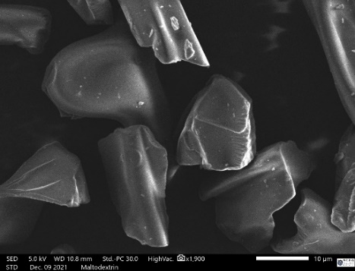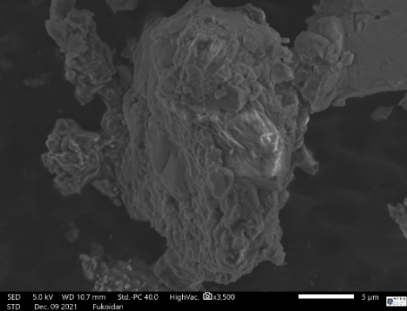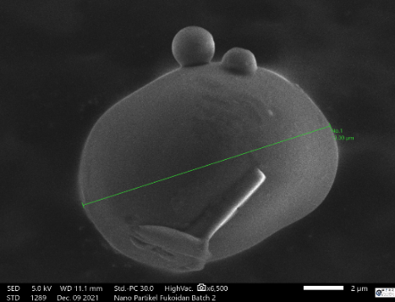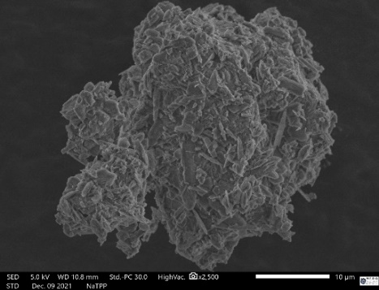

**c d**

**Figure 3.** Scanning Electron Microscopy (SEM) Result a) Maltodextrin b) Fucoidan Purified Extract c). S-TPP d) Fucoidan Purified Extract Encapsulation

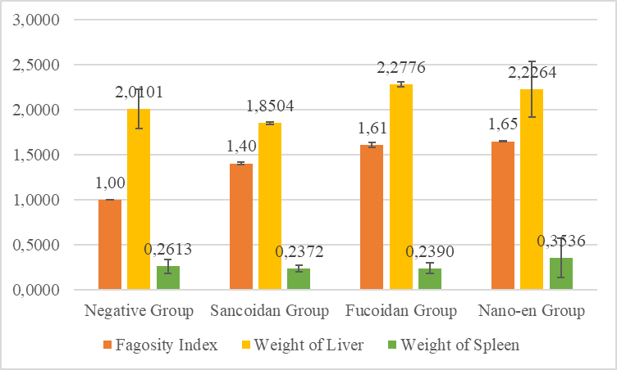

**Figure 4.** Phagocytosis Index, Weight of Liver and Weight of Spleen Value of Animal Group on Immunomodulatory Activity Test

**DISCUSSION**

In the process of fucoidan extraction, the dried brown algae was blended to reduce its size. The reduction in size could cause the cell wall and cell membrane of brown algae to rupture. The rupture of cell walls causes the compounds contained in brown algae to be easier to extract(16). When the particle size was smaller, the surface area in contact with the filter solution became larger, so that the filter solution diffused more easily into the cell. This caused the extraction process to be maximized and the yield was greater.

The extraction process was carried out for 4 hours. The determination of the 4 hour extraction time was based on Junaidi's research(11), which at that time produced the largest yield. The extracted filtrate was separated by centrifugation at 3000 rpm for 10 minutes, then added with 70% ethanol in a ratio of 1:1. The purpose of adding ethanol was to attract, purification and precipitate fucoidan compounds. The precipitate obtained was separated by centrifugation for 10 minutes at 3000 rpm. The precipitate was dried in a oven 40oC for approximately 24 hours. The fucoidan purified extract obtained was dark brown, odorless, in the form of thin flakes with a yield of 2.14%.

Identification of fucoidan with FT-IR spectrophotometer was carried out for qualitative and quantitave analysis based on its functional group. FT-IR spectrophotometry is a method which can used to analyze the characteristics of the functional groups of a compound(17). In this study, analysis was carried out at wave numbers 4000-400 nm-1. The FT-IR profile result could be seen in figure 3.

According to Maciel(18), the functional group of fucoidan was C-O-S with a wave number range of 820-840 cm-1. When compared with the results of this study, it was known that the standard fucoidan obtained the C-O-S group at a wave number of 839 cm-1, and in the purified extract obtained a wave number of 816 cm-1. The results of the analysis also found several other functional groups, namely S=O which indicated the presence of sulfated polysaccharides. In addition, C=C, C=O and CH2-S groups were also found on the standard and the two samples with wave numbers listed in the wave number table above. From these results it was known that the two samples have similar functional groups with standard fucoidan. This indicates that both samples contain fucoidan compounds. The results of this experiment will also be used as a reference for determining fucoidan levels by IR spectrophotometry.

After the fucoidan purified extract was obtained, the next process was the selection of the constituent components for fucoidan encapsulation. The results showed that the crosslinker of chitosan with Na-TPP resulted in the lowest transmittance. Low transmittance could indicate that the particles in it were quite large. The highest transmittance value resulted from the combination of maltodextrin and S-TPP, so the optimization of the encapsulation formula was carried out with these two materials (Table 2).

Based on Design Expert analysis, the optimum formula of nanoencapsulation of fucoidan purified extract on consists of maltodextrin : S-TPP 1 : 5 with desirability 0,921. The average encapsulation size of fucoidan purified extract was 714,5 nm. The zeta potential of nanoencapsulation was measured to determine the properties of surface charge related to the electrostatic interactions of the nanoparticles. The zeta potential was influenced by the composition of the particles and the medium in which the particles were dispersed. The zeta potential value describes the optimization between repulsion or attraction between particles. A good zeta potential value for nanoemulsion preparations was more than +30mV. However, the results of zeta potential measurements of nanoemulsion preparations showed a value of 0.1 mV. From Albert 2016(19), the zeta-capability of maltodextrin was became toward -30 mV when the concentration of maltodextrin was low, which characterize that excessive dilution has a high-quality effect on balance of maltodextrin withinside the solution. The low zeta potential permits the particle to drag collectively and ﬂocculation happens due to the enchantment among Van Der Waal particles. A very high zeta potential will motive a more repulsive force, at the same time as repulsion among debris with the identical electric charge will prevent the aggregation among particle(20).

Figure 3 showed SEM result of fucoidan purified extract encapsulation after drying process with freeze dryer. There was a physical interaction of the maltodextrin and S-TPP as crosslinkers. Figure 3a and 3C showed particle images of maltodextrin and S-TPP and in Figure 3d, it could be seen that there were no intact particles from each crosslinker. This indicated that the two interact to form encapsulations with the active substance. The picture also showed that the fucoidan purified extract could be encapsulated, where in Figure 3b shows a rough surface of the fucoidan purified extract while this is not seen in the 3d encapsulation results.

Fucoidan purified extract and its nano-encapsulation proved to have immunostimulant abilities through non-specific immunomodulatory activity test. Even fucoidan purified extract in the form of nanoencapsulation preparations were proven to have a stronger phagocytic index compared to fucoidan purified extract and also commercial preparations of Sancoidan®. The results of the non-specific immunomodulatory activity are summarized in the bar chart in Figure 4.

The immunomodulatory activity of fucoidan purified extract and its nanoencapsulation had been evaluated towards non-spesific immune responses which can be innate immune systems, this means that responses to foreign materials can arise despite the fact that the body in no way been uncovered to those materials before. The non-spesific immune functio features an early reaction to pathogens that input the body. Phagocytic activity was determined based on the comparison between the slope of the linear regression line between 100% transmittance and time in the test and negative group. The value of the slope of the linear regression line (K) for the negative group, Sancoidan® group, fucoidan and the nanoencapsulation of fucoidan purified extract could be seen in figure 4. The slope value of the linear regression line (K) indicates the magnitude of the phagocytic index. Based on the one-way ANOVA test, the phagocytosis index value between groups had a significant difference (p<0.05). The average value of the phagocytic index indicates the phagocytic activity of phagocytic cells against carbon particles as antigens due to the effect of administering fucoidan purified extract and in nanoencapsulation dosage forms. If the average value of the phagocytosis index is greater than one, it means that the test substance has immunostimulant abilities(21). The immunomodulatory activity of the test material is classified based on its phagocytic index. According to Wagner, the phagocytic index among 1 and 1.5 shows a moderate immunostimulation effect and phagocytic index >1.5 shows a strong immunostimulation effect(22).

Then, the lymphoid organ index was analyzed. Mice was dissected and the lymphoid organs (liver and spleen) were taken. The lymphoid organs were weighed and compared with the control group and the organ index was calculated. The spleen as a secondary lymphoid organ contains B lymphocytes and T lymphocytes which play a role in the process of specific immune responses. In addition, the spleen also contains dendritic cells and macrophages that act as APCs (Antigen Presenting Cells) which serve to present antigens to lymphoid cells. The increase in these immune cells correlated with the weight of the spleen(23). Although the results of statistical tests using one way ANOVA showed no difference in the weight of the liver and spleen in all groups, it was seen that the increase in relative spleen weight indicates the effect of nanoencapsulations of fucoidan purified extract on the stimulant effect.

**CONCLUSION**

Based on the results of the non-specific immune response assay, it can be concluded that the development of nanoencapsulation may increase the phagocytosis index of fucoidan purified brown algae extract. Further molecular studies were needed to demonstrate the molecular activity of this formulation as an immunomodulator.

**ACKNOWLEDGMENTS**

The authors would like to thank the Yayasan Pharmasi Semarang and Indonesian Marine Education and Research Organization Mero Foundation for support of this research.

**References**

1. Hertanto DM, Wiratama BS, Sutanto H, Wungu CDK. Immunomodulation as a Potent COVID-19 Pharmacotherapy: Past, Present and Future. J Inflamm Res [Internet]. 2021 Jul 20 [cited 2022 Apr 17];14:3419–28. Available from: https://www.dovepress.com/immunomodulation-as-a-potent-covid-19-pharmacotherapy-past-present-and-peer-reviewed-fulltext-article-JIR

2. Catanzaro M, Corsini E, Rosini M, Racchi M, Lanni C. Immunomodulators Inspired by Nature : A Review on. 2018;1–17.

3. Yang J, Yang X, Pan W, Wang M, Lu Y, Zhang J, et al. Fucoidan-Supplemented Diet Potentiates Immune Checkpoint Blockage by Enhancing Antitumor Immunity. Front Cell Dev Biol [Internet]. 2021 Aug 9 [cited 2022 Apr 17];9. Available from: /pmc/articles/PMC8382313/

4. PS K, H O, SJ K, W J, F Z, K F, et al. Sulfated polysaccharides effectively inhibit SARS-CoV-2 in vitro. Cell Discov [Internet]. 2020 Dec 1 [cited 2021 Jul 27];6(1). Available from: https://pubmed.ncbi.nlm.nih.gov/32714563/

5. Yim S, Kim K, Kim I, Chun S, Oh T, Kim J, et al. Inhibition of SARS-CoV-2 Virus Entry by the Crude Polysaccharides of Seaweeds and Abalone Viscera In Vitro. 2021;19:1–14.

6. Nagamine T, Nakazato K, Tomioka S, Iha M, Nakajima K. Intestinal Absorption of Fucoidan Extracted from the Brown Seaweed, Cladosiphon okamuranus. Mar Drugs [Internet]. 2015 Jan 1 [cited 2022 Feb 7];13(1):48. Available from: /pmc/articles/PMC4306924/

7. Abdelwahed W, Degobert G, Stainmesse S, Fessi H. Freeze-drying of nanoparticles: Formulation, process and storage considerations. Adv Drug Deliv Rev. 2006 Dec 30;58(15):1688–713.

8. Baek J-S, Yeo EW, Lee YH, Tan NS, Loo SCJ. Controlled-release nanoencapsulating microcapsules to combat inflammatory diseases. Drug Des Devel Ther [Internet]. 2017 Jun 8 [cited 2021 Jul 28];11:1707–17. Available from: https://www.dovepress.com/controlled-release-nanoencapsulating-microcapsules-to-combat-inflammat-peer-reviewed-fulltext-article-DDDT

9. Saloko S, Darmadji P, Setiaji B, Pranoto Y, Anal AK. Encapsulation of coconut shell liquid smoke in chitosan-maltodextrin based nanoparticles. Int Food Res J. 2013;20(3):1269–76.

10. Castro-Cabado M, Parra-Ruiz FJ, Casado AL, San Román J. Thermal crosslinking of maltodextrin and citric acid. Methodology to control the polycondensation reaction under processing conditions. Polym Polym Compos. 2016;24(8):643–54.

11. Junaidi L. Simple Extraction and Molecular Weight Characterization of Fucoidan from Indonesian Sargassum sp. Biopropal Ind [Internet]. 2013 Dec 1 [cited 2021 Jul 28];4(2). Available from: http://ejournal.kemenperin.go.id/biopropal/article/view/808

12. Diniatik, Kusumawati A, Siswanto A, Imtihan ZF, Wahyudi A. Formulation of nanoparticles of ethanol extract of garcinia mangostana l. Leaves as antioxidant with pectin as cross-linker and chitosan variation as polymer. Int J Recent Technol Eng. 2019;8(2 Special Issue 9):779–83.

13. Mohanraj VJ, Chen Y. Nanoparticles-A Review. Trop J Pharm Res [Internet]. 2006 [cited 2022 Apr 17];5(1):561–73. Available from: http://www.tjpr.freehosting.net

14. Sari, Retno;Ardhani, M;Feriza, Meta; Noor A. Polymeric particulate system of carboxymethyl chitosan - diterpen lactone fraction of Andrographis paniculata nees : Characterization and in vitro release study. Int J PharmTech Res. 2016;9(1):120–7.

15. Sebayang LB, Hasibuan AS, Farmasi PS, Pakam L, Serdang D. Test of Immunomodulatory Effects from VCO (Virgin Coconut Oil) In Male Rats. J Bios Logos. 2021;11(2):139–46.

16. Zhang QW, Lin LG, Ye WC. Techniques for extraction and isolation of natural products: a comprehensive review. Chin Med [Internet]. 2018 Apr 17 [cited 2022 Apr 18];13(1). Available from: /pmc/articles/PMC5905184/

17. Barboux R, Bousta F, Di Martino P. Ftir spectroscopy for identification and intra-species characterization of serpula lacrymans. Appl Sci. 2021;11(18).

18. Maciel JS, Chaves LS, Souza BWS, Teixeira DIA, Freitas ALP, Feitosa JPA, et al. Structural characterization of cold extracted fraction of soluble sulfated polysaccharide from red seaweed Gracilaria birdiae. Carbohydr Polym. 2008 Mar 7;71(4):559–65.

19. Albert K, Tóth C, Verasztó B, Vatai G, Koris A. Microencapsulation analysis based on membrane technology: Basic research of spherical, solid precursor microcapsule production. Period Polytech Chem Eng. 2016;60(1):49–53.

20. Kusmayadi A, Adriani L, Abun A, Muchtaridi M, Tanuwiria UH. The microencapsulation of mangosteen peel extract with maltodextrin from arenga starch: Formulation and characterization. J Appl Pharm Sci. 2019;9(3):33–40.

21. Kresno SB. Immunology: Diagnostics and Laboratory Procedures. Jakarta: Faculty of Medicine, University of Indonesia; 2001.

22. Wagner H., Kraus S., Jurcic K. Search for Potent Immunostimulating Agents from Plants and Other Natural Sources. Berlin: Springer; 1999. 1–39 p.

23. Sujono, T.A.; Kusumowati, I.T.D.; Munawaroh R. Immunomodulatory Activity of Muntingia Calabura L. Fruits Using Carbon Clearance Assay and Their Total Flavonoid and Phenolic Contents. Asian J Pharm Clin Res. 2019;13(2):140–5.