Perhitungan Pembuatan Larutan
- Uji Kromatografi Lapis Tipis
Fase Gerak : n-Heksan : etil asetat (6:4) dibuat 10 mL
n-Heksan = x 10 mL = 6 mL
Etil asetat = x 10 mL = 4 mL
- Perhitungan Pengenceran Konsentrasi dari larutan induk
Larutan induk dibuat 100.000 ppm dengan melarutkan 5 gram ekstrak dalam 50 mL etanol 96%
V₁M₁=V₂M₂

Keterangan: V₁ = Volume larutan induk yang dibutuhkan (mL)
V₂= Volume yang akan dibuat (mL)
M₁= Konsentrasi larutan induk (ppm)
M₂= Konsentrasi yang akan dibuat (ppm)
- Pembuatan Konsentrasi 50.000 ppm:
V₁ . 100.000 ppm = 50.000 ppm . 10 mL
V₁ = 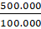
V₁ = 5 mL
Volume etanol 96 % yang dibutuhkan = 10 mL–5 mL = 5 mL
Jadi, dibutuhkan 5 mL larutan induk diencerkan dengan 5mL etanol 96%.
- Pembuatan Konsentrasi 25.000 ppm:
V₁ . 100.000 ppm = 25.000 ppm . 10 mL
V₁ = 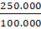
V₁ = 2,5 mL
Volume etanol 96 % yang dibutuhkan = 10 mL–2,5 mL = 7,5 mL
Jadi, dibutuhkan 2,5 mL larutan induk diencerkan dengan 7,5mL etanol 96%.

- Pembuatan Konsentrasi 12.500 ppm:
V₁ . 100.000 ppm = 12.500 ppm . 10 mL
V₁ = 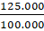
V₁ = 1,25 mL
Volume etanol 96 % yang dibutuhkan = 10 mL–1,25 mL = 8,75 mL
Jadi, dibutuhkan 1,25 mL larutan induk diencerkan dengan 8,75 mL etanol 96%.

Uji aktivitas antibakteri
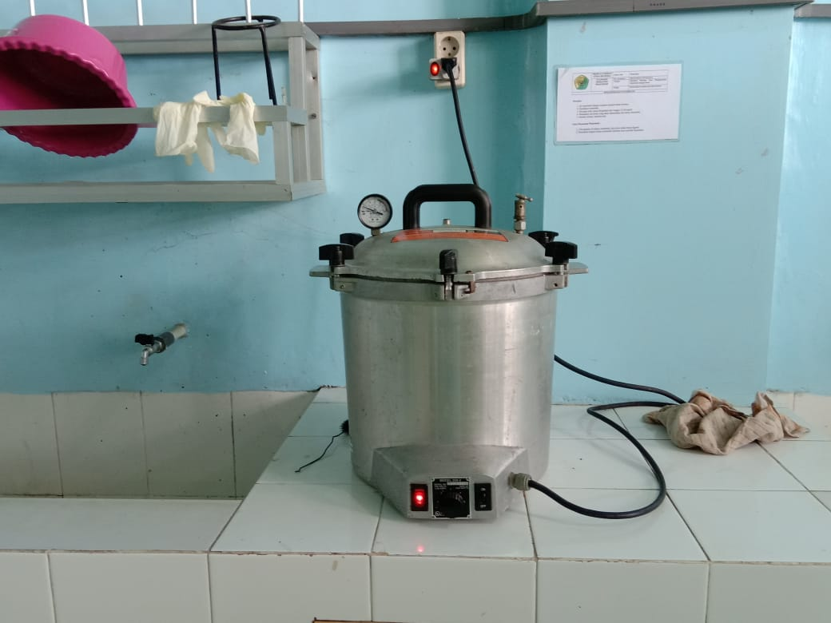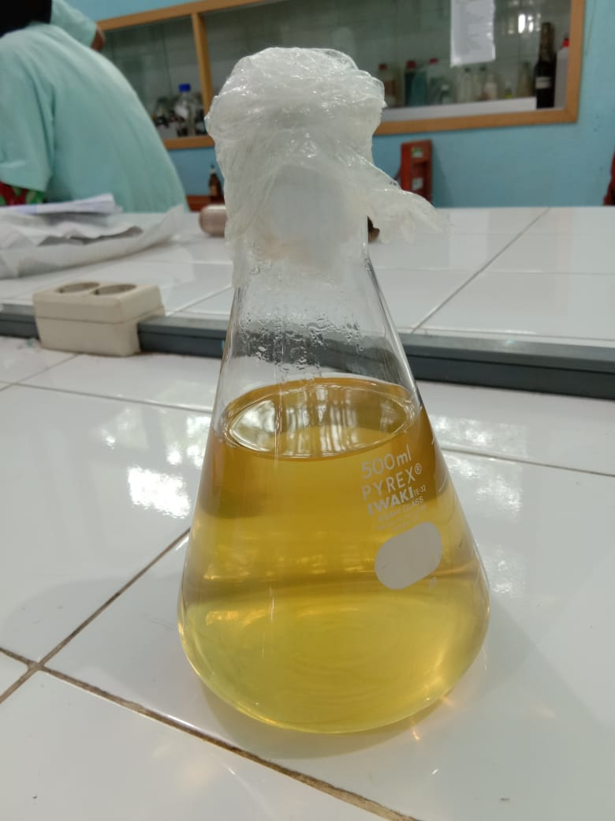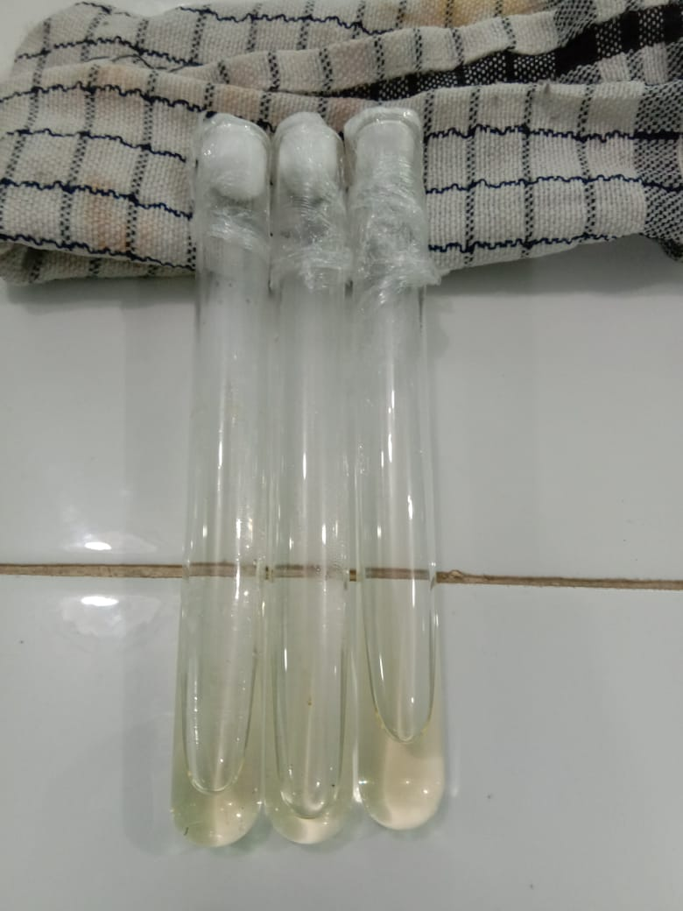
Sterilisasi
Media miring
Nutrient agar

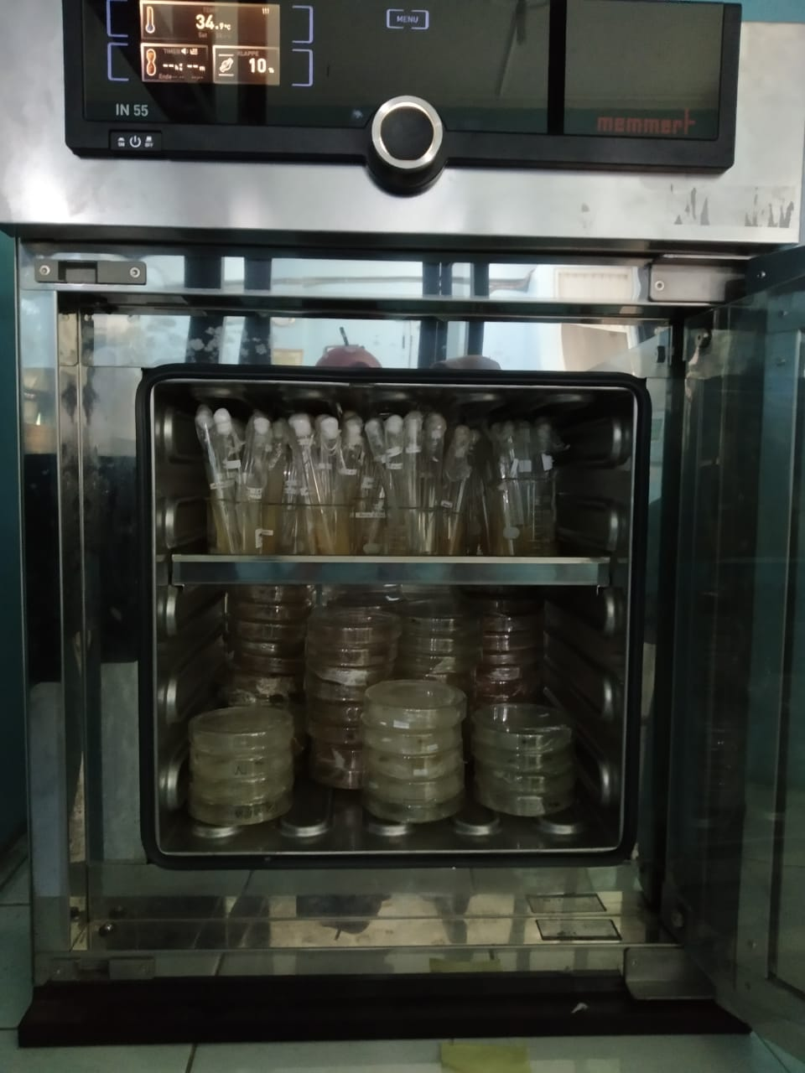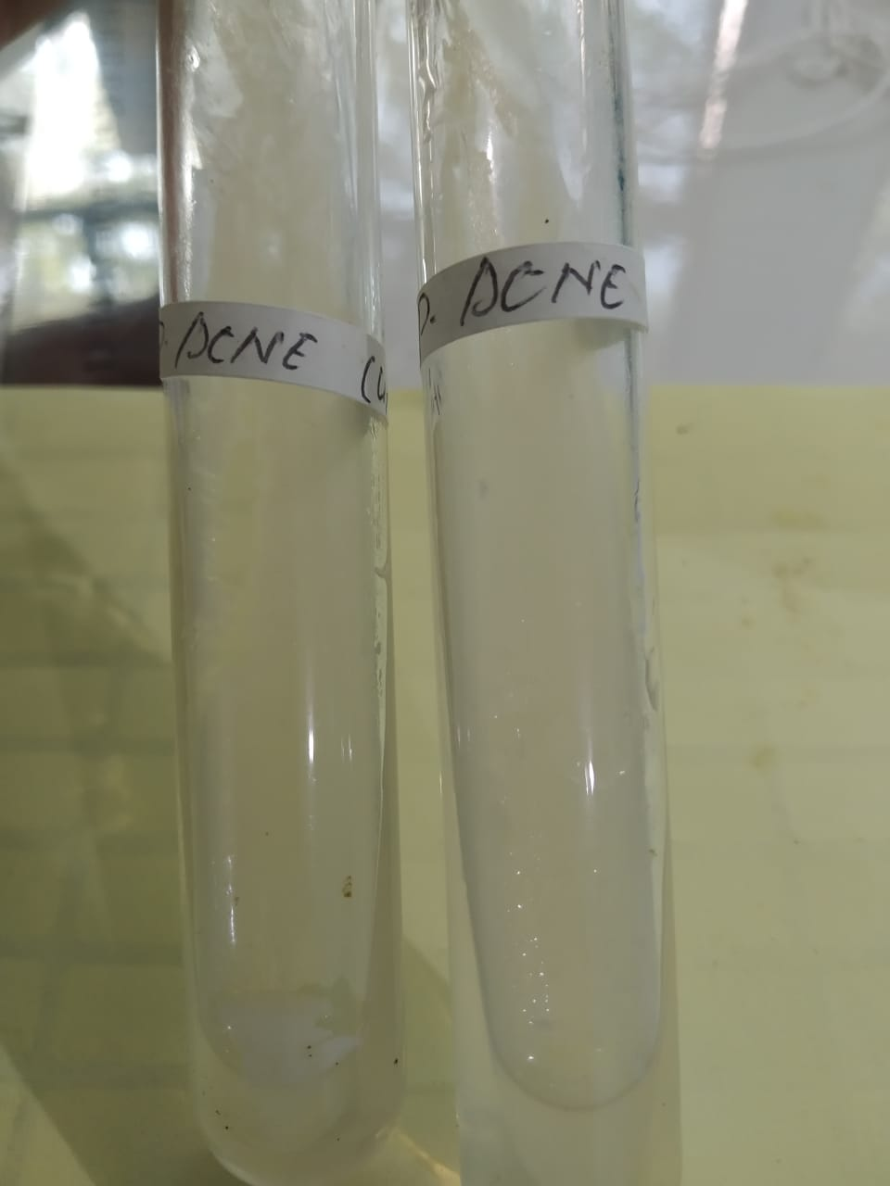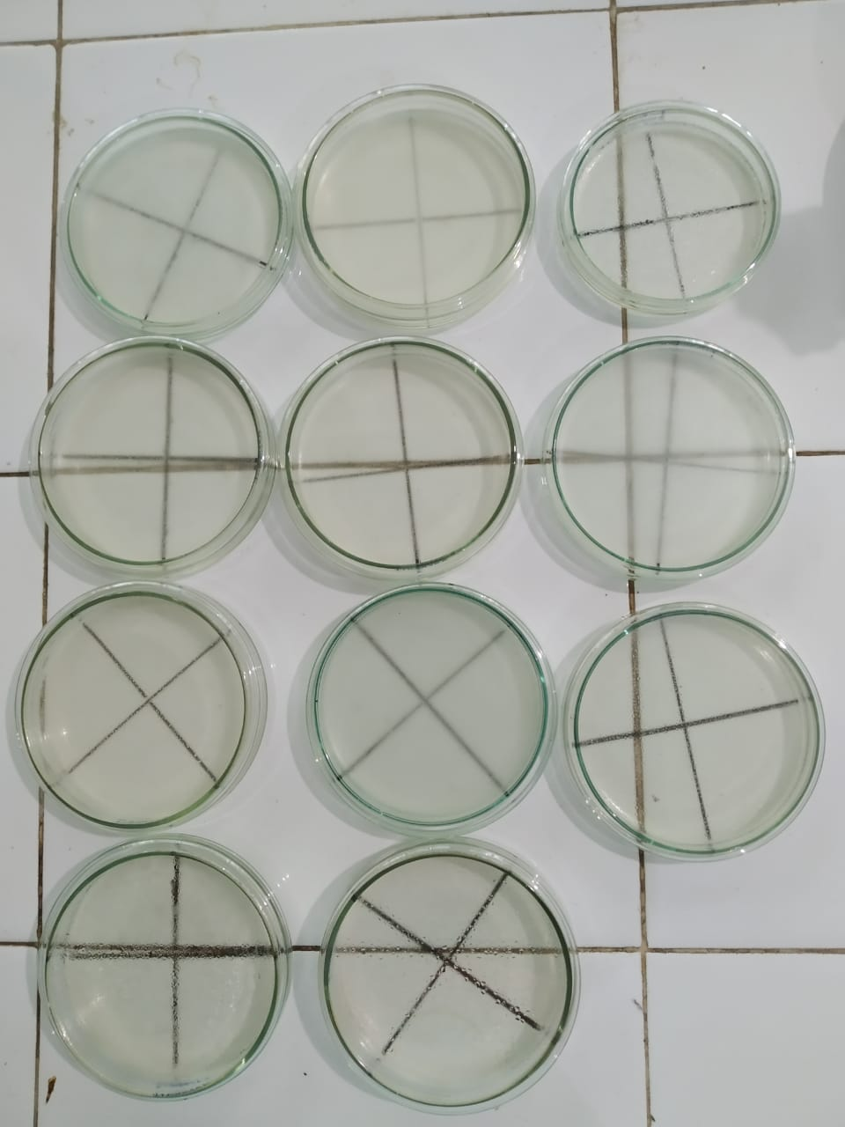
Spared plate
Peremajaan bakteri
Inkubasi
100.000ppm
50.000ppm
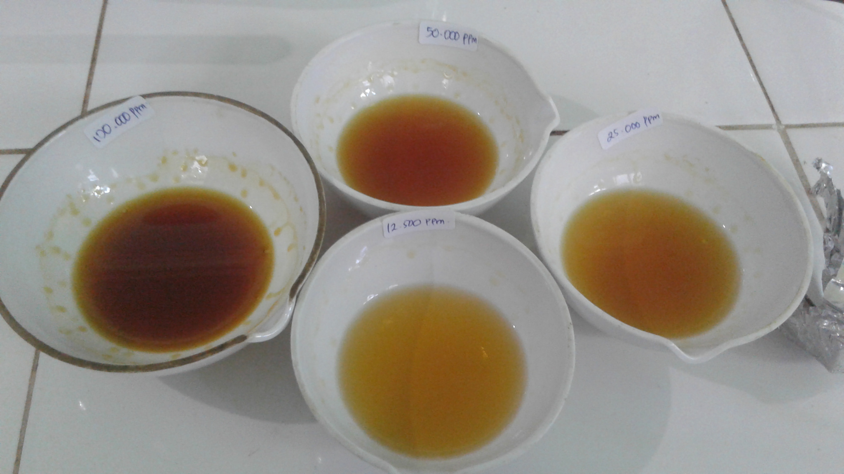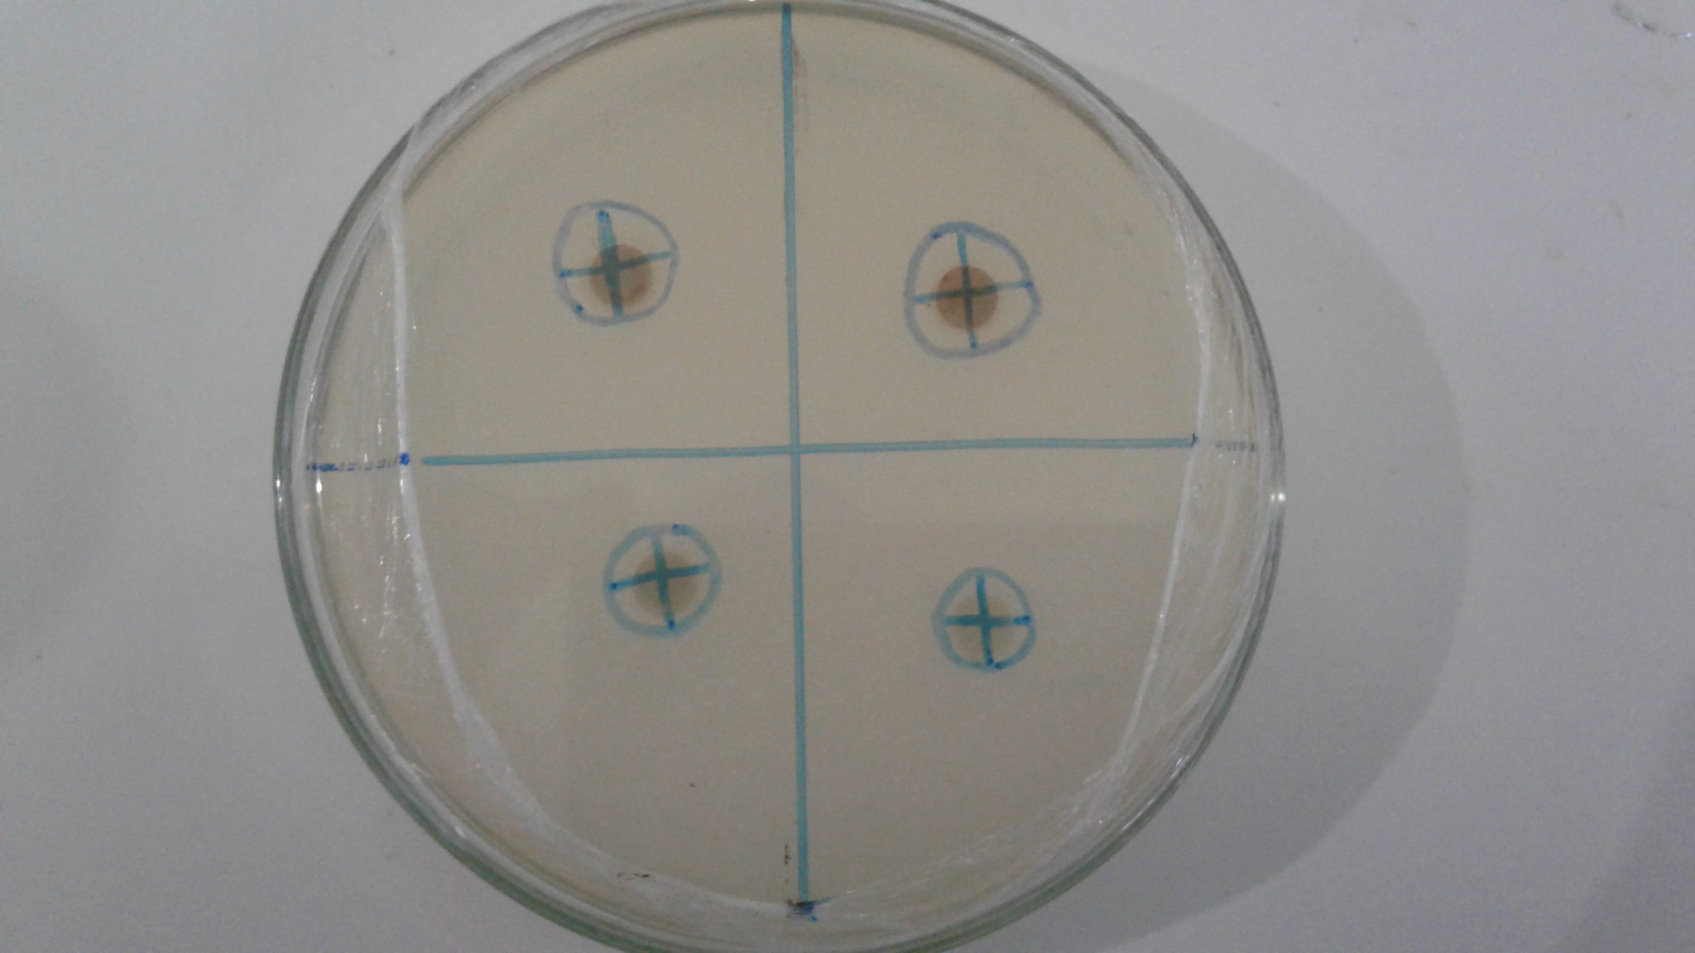
12.500ppm
25.000ppm
Konsentrasi ekstrak
Hasil uji antibakteri

Diameter Daya Hambat = 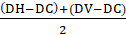
Konsentrasi 100.000 ppm =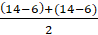 = 8 mm
Konsentrasi 50.000 ppm = 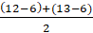 = 6,5 mm
Konsentrasi 25.000 ppm = 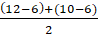 = 5 mm
Konsentrasi 12.500 ppm = 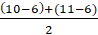 = 4,5 mm

Perhitungan Formulasi
- Formulasi I
- Ekstrak etanol kulit pisang kepok kuning
x 100 gram = 10 gram + 10% = 11 gram
- PVA
x 100 gram = 12 gram + 10% = 13,2 gram
- HPMC
x 100 gram = 2 gram + 10% = 3,3 gram
- Propilenglikol
x 100 gram = 15 gram + 10% = 16,5 gram
- Nipagin
x 100 gram = 0,18 gram + 10% = 0,198 gram
- Nipasol
x 100 gram = 0,02 gram + 10% = 0,022 gram
- Formulasi II
- Ekstrak etanol kulit pisang kepok kuning
x 100 gram = 10 gram + 10% = 11 gram
- PVA
x 100 gram = 12 gram + 10% = 13,2 gram
- HPMC
x 100 gram = 2 gram + 10% = 3,3 gram
- Gliserin
x 100 gram = 15 gram + 10% = 16,5 gram
- Nipagin
x 100 gram = 0,18 gram + 10% = 0,198 gram
- Nipasol
x 100 gram = 0,02 gram + 10% = 0,022 gram
- Formulasi III
- Ekstrak etanol kulit pisang kepok kuning
x 100 gram = 10 gram + 10% = 11 gram
- PVA
x 100 gram = 12 gram + 10% = 13,2 gram
- HPMC
x 100 gram = 2 gram + 10% = 3,3 gram
- Madu
x 100 gram = 15 gram + 10% = 16,5 gram
- Nipagin
x 100 gram = 0,18 gram + 10% = 0,198 gram
- Nipasol
x 100 gram = 0,02 gram + 10% = 0,022 gram

Analisis Data
- Uji Daya Lekat
Tests of Normality
 | formulasi | Shapiro-Wilk
 | formulasi | Statistic | df | Sig.
uji daya lekat hr 0 | formulasi 1 | .775 | 3 | .056
uji daya lekat hr 0 | formulasi 2 | .823 | 3 | .170
uji daya lekat hr 0 | formulasi 3 | .908 | 3 | .411
uji daya lekat hr 1 | formulasi 1 | .907 | 3 | .407
uji daya lekat hr 1 | formulasi 2 | .827 | 3 | .181
uji daya lekat hr 1 | formulasi 3 | .923 | 3 | .463
uji daya lekat hr 7 | formulasi 1 | .997 | 3 | .900
uji daya lekat hr 7 | formulasi 2 | .983 | 3 | .749
uji daya lekat hr 7 | formulasi 3 | .991 | 3 | .817
uji daya lekat hr 14 | formulasi 1 | .851 | 3 | .242
uji daya lekat hr 14 | formulasi 2 | .933 | 3 | .500
uji daya lekat hr 14 | formulasi 3 | .815 | 3 | .150
uji daya lekat hr 21 | formulasi 1 | .765 | 3 | .033
uji daya lekat hr 21 | formulasi 2 | .939 | 3 | .522
uji daya lekat hr 21 | formulasi 3 | 1.000 | 3 | 1.000
uji daya lekat hr 28 | formulasi 1 | .942 | 3 | .537
uji daya lekat hr 28 | formulasi 2 | .956 | 3 | .597
uji daya lekat hr 28 | formulasi 3 | .983 | 3 | .747
a. Lilliefors Significance Correction
Kesimpulan: Sig. >0,05 → dilakukan uji Repeated Measure Anova
Within-Subjects Factors
Measure: ujidayalekat
Hari | Dependent Variable
1 | ujidayalekathr0
2 | ujidayalekathr1
3 | ujidayalekathr7
4 | ujidayalekathr14
5 | ujidayalekathr21
6 | ujidayalekathr28

Mauchly's Test of Sphericityª
Measure: ujidayalekat
Within Subjects Effect | Mauchly's W |  | Approx. Chi-Square | df |  | Sig. | Epsilon^{b}
 |  |  |  |  |  |  | Greenhouse-Geisser |  | Huynh-Feldt | Lower-bound
Hari | .008 |  | 19.712 | 14 |  | .200 | .412 |  | .839 | .200
Tests the null hypothesis that the error covariance matrix of the orthonormalized transformed dependent variables is proportional to an identity matrix.
a. Design: Intercept + formulasi
Within Subjects Design: Hari
b. May be used to adjust the degrees of freedom for the averaged tests of significance. Corrected tests are displayed in the Tests of Within-Subjects Effects table.
Tests of Within-Subjects Effects
Measure: ujidayalekat
Source |  |  |  |  | Type III Sum of Squares |  |  | df | Mean Square | F | Sig.
Hari |  | Sphericity Assumed |  |  | 9.669 |  |  | 5 | 1.934 | 33.403 | .000
 |  | Greenhouse-Geisser |  |  | 9.669 |  |  | 2.059 | 4.696 | 33.403 | .000
 |  | Huynh-Feldt |  |  | 9.669 |  |  | 4.194 | 2.305 | 33.403 | .000
 |  | Lower-bound |  |  | 9.669 |  |  | 1.000 | 9.669 | 33.403 | .001
Hari * formulasi |  | Sphericity Assumed |  |  | 2.505 |  |  | 10 | .251 | 4.327 | .001
 |  | Greenhouse-Geisser |  |  | 2.505 |  |  | 4.118 | .608 | 4.327 | .020
 |  | Huynh-Feldt |  |  | 2.505 |  |  | 8.388 | .299 | 4.327 | .002
 |  | Lower-bound |  |  | 2.505 |  |  | 2.000 | 1.253 | 4.327 | .069
Error(Hari) |  | Sphericity Assumed |  |  | 1.737 |  |  | 30 | .058
 |  | Greenhouse-Geisser |  |  | 1.737 |  |  | 12.353 | .141
 |  | Huynh-Feldt |  |  | 1.737 |  |  | 25.164 | .069
 |  | Lower-bound |  |  | 1.737 |  |  | 6.000 | .289
Kesimpilan: Sig. <0,05: H0 ditolak, Ha diterima
- Uji Daya Sebar
Tests of Normality
 | formulasi | Shapiro-Wilk
 | formulasi | Statistic | df | Sig.
uji daya sebar hr 0 | 1.00 | .750 | 3 | .000
uji daya sebar hr 0 | 2.00 | .750 | 3 | .000
uji daya sebar hr 0 | 3.00 | 1.000 | 3 | 1.000
uji daya sebar hr 1 | 1.00 | .750 | 3 | .000
uji daya sebar hr 1 | 2.00 | .750 | 3 | .000
uji daya sebar hr 1 | 3.00 | .893 | 3 | .363
uji daya sebar hr 7 | 1.00 | .750 | 3 | .000
uji daya sebar hr 7 | 2.00 | .987 | 3 | .780
uji daya sebar hr 7 | 3.00 | .750 | 3 | .000
uji daya sebar hr 14 | 1.00 | 1.000 | 3 | 1.000
uji daya sebar hr 14 | 2.00 | .750 | 3 | .000
uji daya sebar hr 14 | 3.00 | .750 | 3 | .000
uji daya sebar hr 21 | 1.00 | .987 | 3 | .780
uji daya sebar hr 21 | 2.00 | .871 | 3 | .298
uji daya sebar hr 21 | 3.00 | .964 | 3 | .637
uji daya sebar hr 28 | 1.00 | .750 | 3 | .000
uji daya sebar hr 28 | 2.00 | .750 | 3 | .000
uji daya sebar hr 28 | 3.00 | .750 | 3 | .000
a. Lilliefors Significance Correction
Kesimpulan: Sig. <0,05 → dilakukan uji Friedman
Test Statisticsª
N | 9
Chi-Square | 15.849
Df | 5
Asymp. Sig. | .007
a. Friedman Test
Kesimpulan: Sig. <0,05: H0 ditolak, Ha diterima

- Uji Viskositas
Tests of Normality
 | formulasi | Shapiro-Wilk
 | formulasi | Statistic | df | Sig.
uji viskositas hr 0 | formulasi 1 | .750 | 3 | .000
uji viskositas hr 0 | formulasi 2 | .750 | 3 | .000
uji viskositas hr 0 | formulasi 3 | .750 | 3 | .000
uji viskositas hr 1 | formulasi 1 | 1.000 | 3 | 1.000
uji viskositas hr 1 | formulasi 2 | .750 | 3 | .000
uji viskositas hr 1 | formulasi 3 | .987 | 3 | .780
uji viskositas hr 7 | formulasi 1 | .750 | 3 | .000
uji viskositas hr 7 | formulasi 2 | .964 | 3 | .637
uji viskositas hr 7 | formulasi 3 | .750 | 3 | .000
uji viskositas hr 14 | formulasi 1 | 1.000 | 3 | 1.000
uji viskositas hr 14 | formulasi 2 | .987 | 3 | .780
uji viskositas hr 14 | formulasi 3 | .750 | 3 | .000
uji viskositas hr 21 | formulasi 1 | 1.000 | 3 | 1.000
uji viskositas hr 21 | formulasi 2 | .964 | 3 | .637
uji viskositas hr 21 | formulasi 3 | .923 | 3 | .463
uji viskositas hr 28 | formulasi 1 | .832 | 3 | .194
uji viskositas hr 28 | formulasi 2 | .964 | 3 | .637
uji viskositas hr 28 | formulasi 3 | .964 | 3 | .637
a. Lilliefors Significance Correction
Kesimpulan: Sig. <0,05 → dilakukan uji Friedman
Test Statisticsª
N | 9
Chi-Square | 4.904
df | 5
Asymp. Sig. | .428
a. Friedman Test
Kesimpulan: Sig. >0,05: Ha ditolak, H0 diterima

- Uji Waktu Mengering
Tests of Normality
 | formulasi | Shapiro-Wilk
 | formulasi | Statistic | df | Sig.
uji waktu kering hr 0 | formulasi 1 | .994 | 3 | .852
uji waktu kering hr 0 | formulasi 2 | .945 | 3 | .549
uji waktu kering hr 0 | formulasi 3 | .818 | 3 | .157
uji waktu kering hr 1 | formulasi 1 | .798 | 3 | .111
uji waktu kering hr 1 | formulasi 2 | .838 | 3 | .209
uji waktu kering hr 1 | formulasi 3 | .997 | 3 | .900
uji waktu kering hr 7 | formulasi 1 | .959 | 3 | .612
uji waktu kering hr 7 | formulasi 2 | .962 | 3 | .624
uji waktu kering hr 7 | formulasi 3 | .871 | 3 | .298
uji waktu kering hr 14 | formulasi 1 | .937 | 3 | .514
uji waktu kering hr 14 | formulasi 2 | .810 | 3 | .138
uji waktu kering hr 14 | formulasi 3 | .923 | 3 | .463
uji waktu kering hr 21 | formulasi 1 | .893 | 3 | .363
uji waktu kering hr 21 | formulasi 2 | .800 | 3 | .115
uji waktu kering hr 21 | formulasi 3 | .985 | 3 | .766
uji waktu kering hr 28 | formulasi 1 | .778 | 3 | .063
uji waktu kering hr 28 | formulasi 2 | .960 | 3 | .618
uji waktu kering hr 28 | formulasi 3 | .892 | 3 | .359
a. Lilliefors Significance Correction
Kesimpulan: Sig. >0,05 → dilakukan uji Repeated Measure Anova
Within-Subjects Factors
Measure: ujiwaktukering
hari | Dependent Variable
1 | ujiwaktukeringhr0
2 | ujiwaktukeringhr1
3 | ujiwaktukeringhr7
4 | ujiwaktukeringhr14
5 | ujiwaktukeringhr21
6 | ujiwaktukeringhr28

Mauchly's Test of Sphericityª
Measure: ujiwaktukering
Within Subjects Effect | Mauchly's W |  | Approx. Chi-Square |  | df | Sig. | Epsilon^{b}
 |  |  |  |  |  |  | Greenhouse-Geisser |  |  | Huynh-Feldt |  | Lower-bound
hari | .000 |  | 73.791 |  | 14 | .000 | .218 |  |  | .226 |  | .200
Tests the null hypothesis that the error covariance matrix of the orthonormalized transformed dependent variables is proportional to an identity matrix.
a. Design: Intercept
Within Subjects Design: hari
b. May be used to adjust the degrees of freedom for the averaged tests of significance. Corrected tests are displayed in the Tests of Within-Subjects Effects table.
Tests of Within-Subjects Effects
Measure: ujiwaktukering
Source |  |  |  | Type III Sum of Squares |  |  |  | df | Mean Square |  | F |  | Sig.
hari |  | Sphericity Assumed |  | 609.110 |  |  |  | 5 | 121.822 |  | 24.863 |  | .000
 |  | Greenhouse-Geisser |  | 609.110 |  |  |  | 1.090 | 558.942 |  | 24.863 |  | .001
 |  | Huynh-Feldt |  | 609.110 |  |  |  | 1.130 | 539.090 |  | 24.863 |  | .001
 |  | Lower-bound |  | 609.110 |  |  |  | 1.000 | 609.110 |  | 24.863 |  | .001
Error(hari) |  | Sphericity Assumed |  | 195.990 |  |  |  | 40 | 4.900
 |  | Greenhouse-Geisser |  | 195.990 |  |  |  | 8.718 | 22.481
 |  | Huynh-Feldt |  | 195.990 |  |  |  | 9.039 | 21.682
 |  | Lower-bound |  | 195.990 |  |  |  | 8.000 | 24.499
Kesimpulan: Sig. <0,05

Pairwise Comparisons
Measure: ujiwaktukering
(I) hari | (J) hari | Mean Difference (I-J) | Std. Error | Sig.^{b} | 95% Confidence Interval for Difference^{b}
 |  |  |  |  | Lower Bound | Upper Bound
1 | 2 | -.772 | .338 | .052 | -1.551 | .006
1 | 3 | -2.263* | .351 | .000 | -3.073 | -1.453
1 | 4 | -3.301* | .554 | .000 | -4.579 | -2.023
1 | 5 | -5.849* | 1.362 | .003 | -8.989 | -2.709
1 | 6 | -9.911* | 1.831 | .001 | -14.132 | -5.690
2 | 1 | .772 | .338 | .052 | -.006 | 1.551
2 | 3 | -1.491* | .145 | .000 | -1.825 | -1.157
2 | 4 | -2.529* | .442 | .000 | -3.548 | -1.510
2 | 5 | -5.077* | 1.145 | .002 | -7.717 | -2.436
2 | 6 | -9.139* | 1.602 | .000 | -12.832 | -5.446
3 | 1 | 2.263* | .351 | .000 | 1.453 | 3.073
3 | 2 | 1.491* | .145 | .000 | 1.157 | 1.825
3 | 4 | -1.038* | .383 | .027 | -1.920 | -.156
3 | 5 | -3.586* | 1.079 | .010 | -6.073 | -1.098
3 | 6 | -7.648* | 1.536 | .001 | -11.189 | -4.107
4 | 1 | 3.301* | .554 | .000 | 2.023 | 4.579
4 | 2 | 2.529* | .442 | .000 | 1.510 | 3.548
4 | 3 | 1.038* | .383 | .027 | .156 | 1.920
4 | 5 | -2.548* | .886 | .021 | -4.592 | -.504
4 | 6 | -6.610* | 1.334 | .001 | -9.686 | -3.534
5 | 1 | 5.849* | 1.362 | .003 | 2.709 | 8.989
5 | 2 | 5.077* | 1.145 | .002 | 2.436 | 7.717
5 | 3 | 3.586* | 1.079 | .010 | 1.098 | 6.073
5 | 4 | 2.548* | .886 | .021 | .504 | 4.592
5 | 6 | -4.062* | .508 | .000 | -5.233 | -2.892
6 | 1 | 9.911* | 1.831 | .001 | 5.690 | 14.132
6 | 2 | 9.139* | 1.602 | .000 | 5.446 | 12.832
6 | 3 | 7.648* | 1.536 | .001 | 4.107 | 11.189
6 | 4 | 6.610* | 1.334 | .001 | 3.534 | 9.686
6 | 5 | 4.062* | .508 | .000 | 2.892 | 5.233

